Beneficiaries list for 2022-23
Scheme name | National Action Plan for Senior Citizen (NAPSrC)
Name of organization | Samaj Sewa Sansthan
Project type | Senior Citizen Home for 25 Inmates
Project location | Gram Heerpur Atariya Sidhauli District-Sitapur pin code-261303

Sl.No. | Name | Gender | Age | Medical Condition | Duration of each beneficiary since they are in the center | Photograph
1 | krishna Devi | Female | 61 Years | No any complaint | 01-04-2022 to 31-03-2023 | 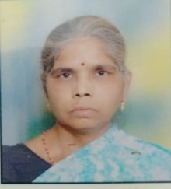
2 | Jashoda | Female | 87 Years | Scalp Itching | 01-04-2020 to 31-03-2023 | 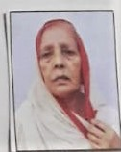
3 | Ramrani | Female | 67 Years | Back Pain  B/L vision Weakness | 01-04-2020 to 31-03-2023 | 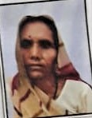
4 | Phoolmati | Female | 72 Years | General Weakness  B/L knee joint pain | 30-08-2020 to 31-03-2023 | 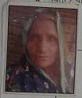
5 | Hema | Female | 77 Years | Epigastric pain  General Weakness | 30-08-2020 to 31-03-2023 | 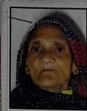
6 | Chandrani | Female | 76 Years | Back Pain  lower leg radiating pain | 23-08-2020 to 31-03-2023 | 
7 | Sonapati | Female | 77 Years | No any complaint | 14-08-2020 to 31-03-2023 | 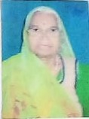
8 | Phoolvasa | Female | 76 Years | Dry cough  General Weakness | 01-11-2020 to 31-03-2023 | 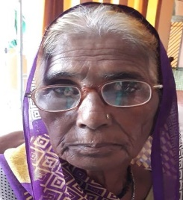
9 | Sevakanti | Female | 80 Years | Epigastric pain | 01-07-2021 to 31-03-2023 | 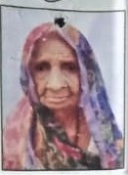
10 | Rani singh | Female | 63 Years | No any complaint | 01-07-2021 to 31-03-2023 | 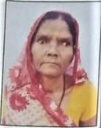
11 | Champa Chakravarti | Female | 87 Years | HTN x 13 years  (take treatment previously)  General Weakness | 01-07-2021 to 31-03-2023 | 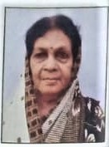
12 | Asha Mishra | Female | 62 Years | Epigastric Pain  General Weakness  Burning MI curation | 01-07-2021 to 31-03-2023 | 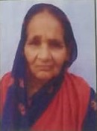
13 | Hardae | Female | 76 Years | HTN x 1 Year  Back Pain  General Weakness | 06-10-2021 to 31-03-2023 | 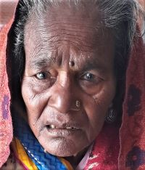
14 | Ramkali | Female | 77 Years | Knee joint Pain  General Weakness | 01-04-2020 to 31-03-2023 | 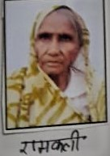
15 | Sushma | Female | 69 Years | Back Pain  Knee joint Pain  General Weakness | 19-08-2020 to 31-03-2023 | 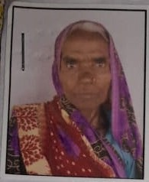
16 | Rajja Devi | Female | 73 Years | Severe Back Pain  lower leg Radiating pain | 16-08-2020 to 31-03-2023 | 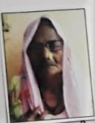
17 | Kamla Devi Yadav | Female | 62 Years | General Weakness | 25-05-2022 to 31-03-2023 | 
18 | Pushpa Tripathi | Female | 81 Years | Fall from height x 1 year before  Cervical Pain upper limbs tremor | 01-08-2022 to 31-03-2023 | 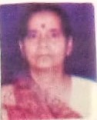
19 | Ramchandra | Male | 67 Years | No any Complaint | 23-05-2022 to 31-03-2023 | 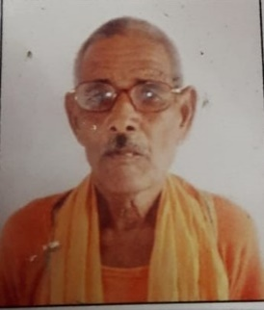
20 | Heeralal | Male | 67 Years | Asthma x 12 years  General Weakness | 01-09-2020 to 31-03-2023 | 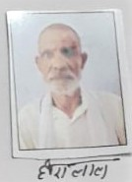
21 | Babu | Male | 65 Years | General Weakness | 09-10-2021 to 31-03-2023 | 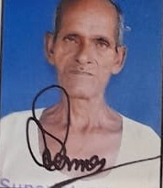
22 | Rajkumar Yadav | Male | 72 Years | Full from Roof x 03 years  Back Pain  Numbness in B/L shoulder  Urine Hesitantly & dribbling | 15-12-2020 to 31-03-2023 | 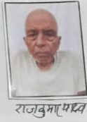
23 | Rajkumar Gautam | Male | 72 Years | No any complaint | 15-12-2020 to 31-03-2023 | 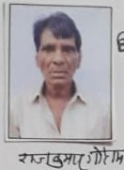
24 | Nandlal yadav | Male | 70 Years | Fungal Infection | 01-10-2020 to 31-03-2023 | 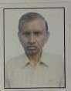
25 | Ayodhya | Male | 73 years | General Weakness  Back Pain | 01-04-2020 to 31-03-2023 | 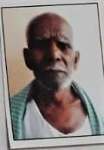
26 | Churailal | Male | 73 years | Back Pain | 17-11-2021 to 31-03-2023 | 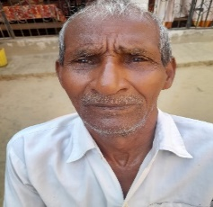

Place: Sitapur Signature:
Date: Name: Sushma Tiwari
Designation: Manager
Name of the Organization: Samaj Sewa Sansthan

